Lab # 06

System Programming



Teacher | Bibi Areej Khan
Student Name | Muhammad Ahmad Khan
Registration No | 23JZBCS0238

Department of CS&IT
University of Engineering and Technology Peshawar
(Jalozai Campus)

Lab No. 6 – Background Processes & Task/Data Division in Linux

Objectives
After completing this lab, students will be able to:
- Run and manage background processes in Linux.
- Use Linux job control commands like jobs, bg, and fg.
- Implement functional task division using fork().
- Implement data division by splitting work among processes.
- Understand inter-process communication using pipe().
- Display and manage process IDs using terminal commands like kill.

Theory
In Linux, a process is a program in execution. Linux is a multitasking operating system, so it can run multiple processes at the same time. To manage processes efficiently, Linux provides several important features such as:
- Background processes
- Job control
- Task division
- Data division
- Inter-Process Communication (IPC)
These concepts help improve:
- system performance
- resource utilization
- multitasking
- parallel execution
They are widely used in Operating Systems, System Programming, and Parallel Computing.

Lab Task 1 – Background Processes and Job Control

Objective
To perform job control in Linux using background and foreground execution.

Theory
A background process runs without occupying the terminal continuously. Linux provides job control commands to manage such processes.

Important Commands
- & → runs a command in background
- jobs → shows background/stopped jobs
- Ctrl + Z → stops/suspends the foreground process
- bg → resumes a stopped process in background
- fg → brings background process to foreground

Commands

Step 1: Run a command in background
sleep 60 &

Step 2: Verify using jobs
jobs

Step 3: Run a foreground process
sleep 100
Now press:
Ctrl + Z
This stops the running process.

Step 4: Resume stopped process in background
bg

Step 5: Verify again
jobs

Step 6: Bring it back to foreground
fg

Screenshot

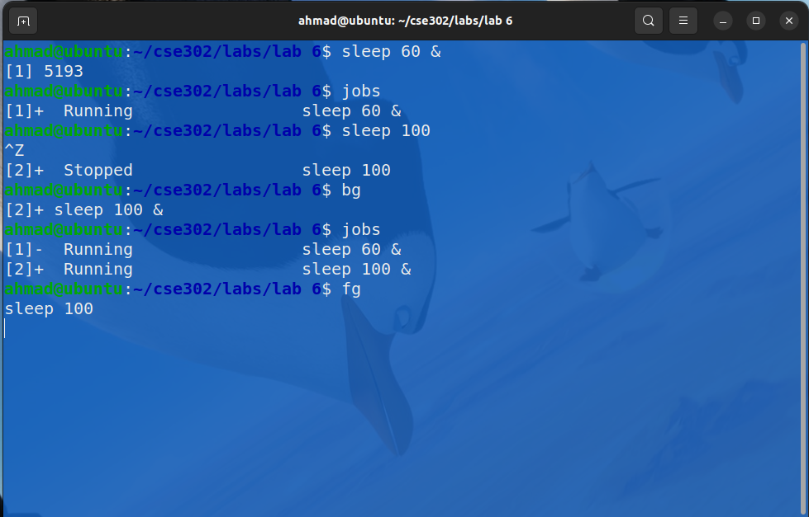

Lab Task 2 – Functional Task Division using fork()

Objective
To create multiple processes where:
- one process performs input
- second process performs processing
- third process performs output

Theory
Using fork(), Linux creates a new child process. By calling fork() multiple times, we can divide a program into separate functional parts. In this lab:
- Input process takes numbers from user
- Processing process divides data into two halves and computes sum of each half
- Output process displays final results
This is called functional task division.

C Program
#include <stdio.h>
#include <unistd.h>
#include <sys/wait.h>

int main() {
int numbers[6];
int sum1 = 0, sum2 = 0;
pid_t pid1, pid2;

// First child for input
pid1 = fork();

if (pid1 == 0) {
printf("INPUT PROCESS:\n");
printf("Enter 6 numbers:\n");
for (int i = 0; i < 6; i++) {
scanf("%d", &numbers[i]);
}

printf("Numbers entered: ");
for (int i = 0; i < 6; i++) {
printf("%d ", numbers[i]);
}
printf("\n");

return 0;
}
else {
wait(NULL); // Wait for input process to complete

// Since child and parent do not share memory directly after fork,
// for demonstration we assign sample values again in parent
printf("\nPROCESSING PROCESS:\n");
numbers[0] = 10;
numbers[1] = 20;
numbers[2] = 30;
numbers[3] = 40;
numbers[4] = 50;
numbers[5] = 60;

pid2 = fork();

if (pid2 == 0) {
for (int i = 0; i < 3; i++) {
sum1 += numbers[i];
}
for (int i = 3; i < 6; i++) {
sum2 += numbers[i];
}

printf("First half sum = %d\n", sum1);
printf("Second half sum = %d\n", sum2);
printf("Total sum = %d\n", sum1 + sum2);

return 0;
}
else {
wait(NULL);
printf("\nOUTPUT PROCESS:\n");
printf("Final result displayed successfully.\n");
}
}

return 0;
}

Screenshot

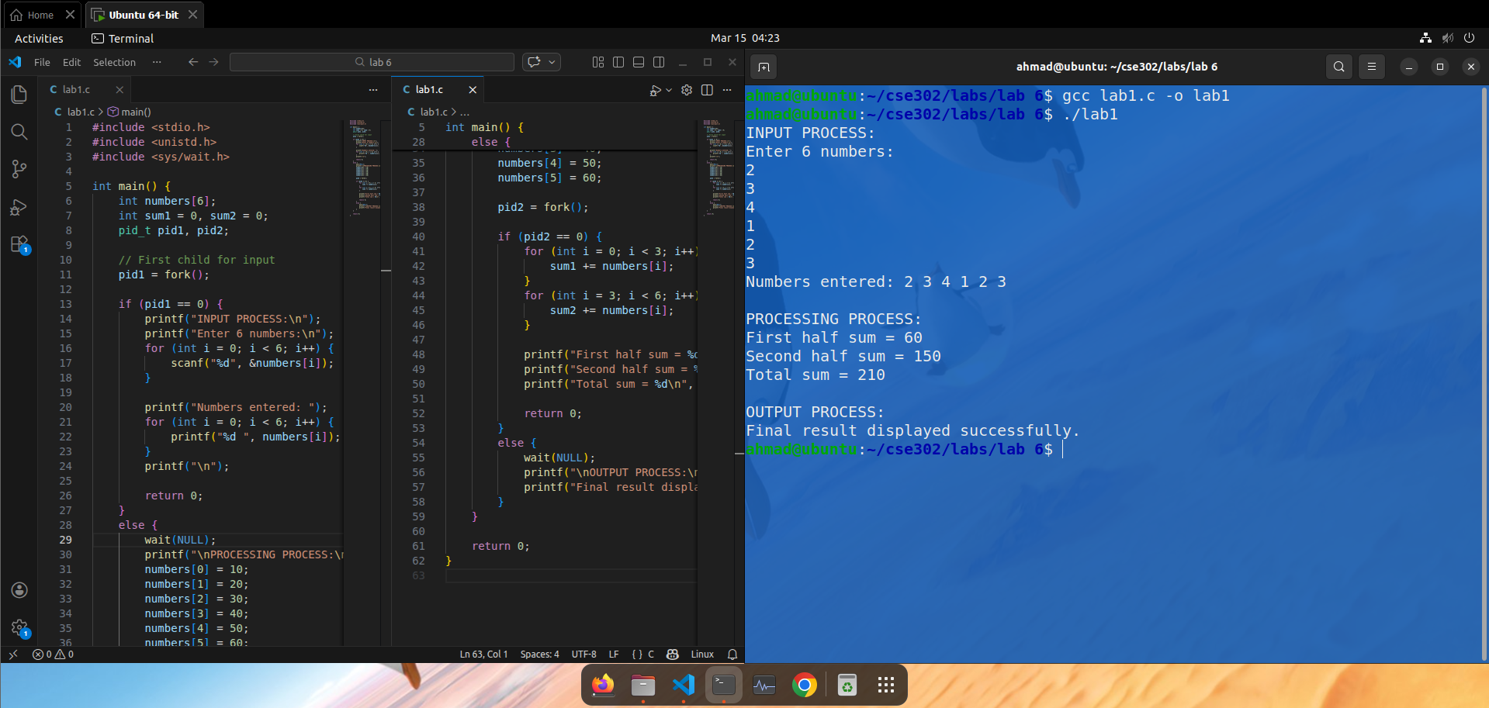Report
Because memory is not automatically shared between parent and child after fork(), the parent process cannot directly use values entered by child unless shared memory or pipe is used. For simplicity, this program demonstrates the concept of functional division clearly.
If you want, I can also give you a better version using pipe() so the input values properly move from one process to another. That version is more correct technically.

Lab Task 3 – Pipe Communication with Long Process and PID

Objective
To write a C program that:
- uses pipe() for communication between parent and child
- runs a long process using sleep() in child
- displays PID so process can be terminated using kill

Theory
A pipe is an IPC mechanism that allows one process to send data to another.
- pipe(fd) creates two file descriptors
- fd[0] is used for reading
- fd[1] is used for writing
In this lab:
- parent sends a message to child through pipe
- child prints its PID
- child sleeps for some time to simulate a long-running process
- user can terminate it from another terminal using kill PID

C Program
#include <stdio.h>
#include <unistd.h>
#include <string.h>
#include <sys/wait.h>

int main() {
int fd[2];
pid_t pid;
char message[100];

pipe(fd);

pid = fork();

if (pid == 0) {
// Child process
close(fd[1]); // Close write end

read(fd[0], message, sizeof(message));
printf("Child Process Received Message: %s\n", message);
printf("Child PID: %d\n", getpid());
printf("Child is running a long process (sleep for 30 seconds)...\n");

sleep(30);

printf("Child process finished.\n");
close(fd[0]);
}
else {
// Parent process
close(fd[0]); // Close read end

char parentMsg[] = "Hello from Parent through Pipe!";
write(fd[1], parentMsg, strlen(parentMsg) + 1);

printf("Parent Process PID: %d\n", getpid());
printf("Message sent to child.\n");
printf("Use kill command from terminal if needed.\n");

close(fd[1]);
wait(NULL);
}

return 0;
}

Screenshot

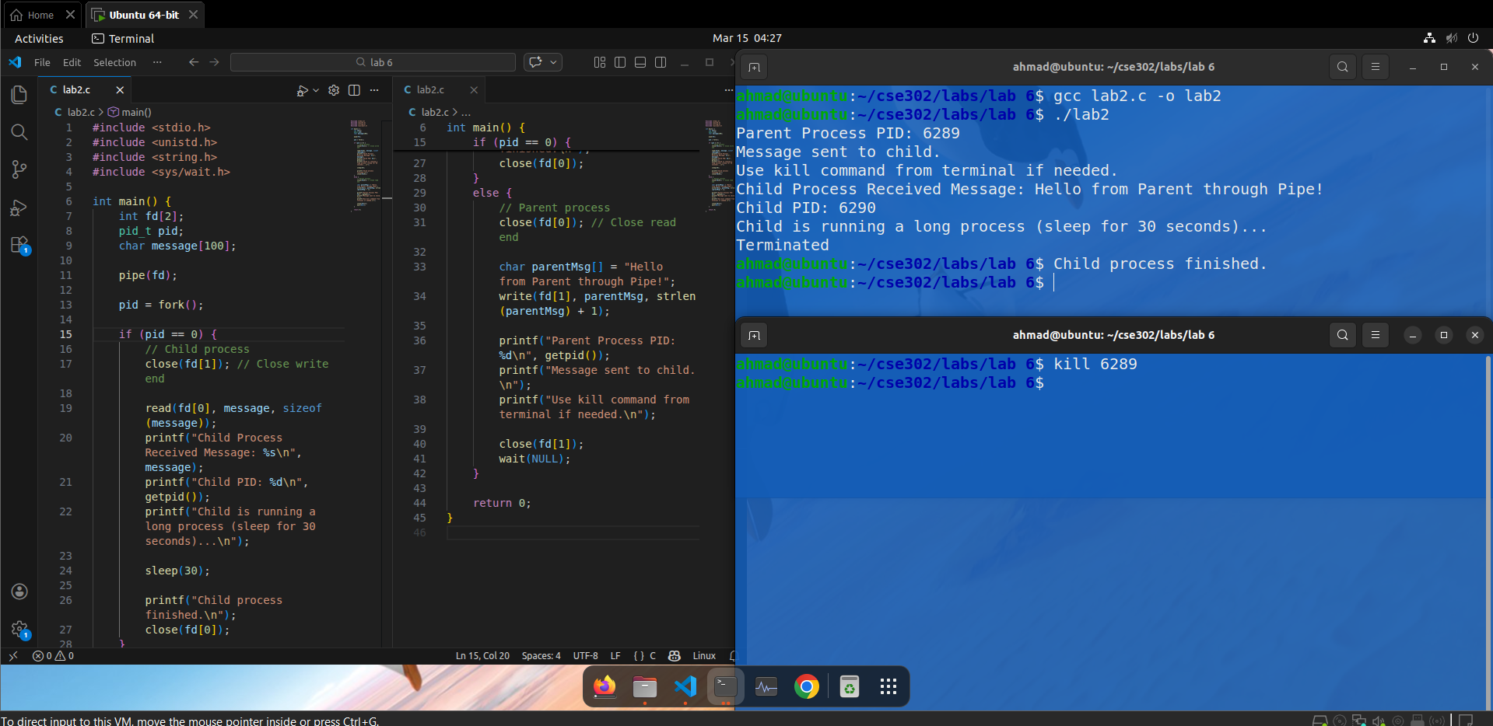How to Terminate Using kill
While the child is sleeping, open another terminal and run:
kill 6289
Replace 3457 with the actual PID shown by the child process.

Conclusion
In this lab, we studied important Linux process management concepts. We learned how to run commands in the background, stop and resume them, and move them between background and foreground using job control commands such as jobs, bg, and fg. We also implemented functional task division using fork(), where different processes handled input, processing, and output tasks. Finally, we used pipe() for inter-process communication and observed how process IDs can be used to terminate running processes through the kill command.
Overall, this lab helped us understand how Linux handles multitasking, process control, and communication between processes, which are essential concepts in System Programming and Operating Systems.

